Introduction

The APEXA API is an outbound web service that allows our clients to pull advisor, shareholder, corporate and contract information from APEXA back into their own environment.

Connecting to the API & Testing

# API Credentials

The APEXA platform uses a special CITS Feed account to allow your organization to access the API. The administrator of APEXA for your organization will need to create an account within the test (UAT) and production environments.

In order to set up this account, you’ll need an accessible inbox. This address should be provided to your APEXA administrator. They will set up an account with the role type “CITS Feed” and an email will be sent to the inbox you’ve provided. Proceed with the set-up instructions – the username (email) and password will become the credentials you need to access the API in the respective environment.

# Testing the API

As mentioned, the API is available in the testing (UAT) environment. However, this cannot be made available to your organization until the UAT environment is deployed for your team. This happens the week after training. At that point, the instructions above should be executed.

Working with the API

# Step One – Determining the Records That Have Changed

The first call you’ll make is a “Changed Producer Listing Request.” This method allows you to pass a Start Date/Time and an End Date/Time. Note the Date range should be exactly 1 day (Sample Request - Figure 1)

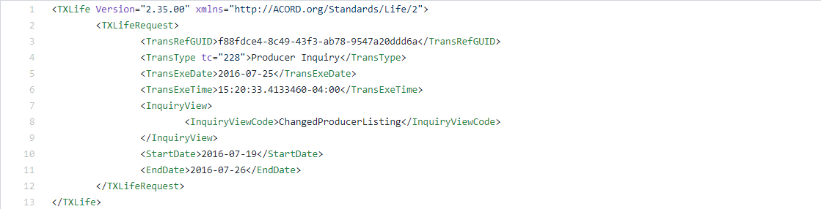

20

Figure

The response will contain each “party” (advisor, shareholder or corporation) that has had a change to their profile within the time frame passed through in the first call (Sample Response – Figure 2).

# Step Two – Pulling back Advisor, Shareholder and/or Corporate Records

Once you’ve received the list of records that have changed (the response to the “Changed Producer Listing” request), you will take those IDs and pass them back to APEXA to get the full files for these advisors, shareholders or corporations.

The easiest request to use for this is the “Multiple Producers Request by ID” request (Sample Request – Figure 3). This request allows you to pass all of the IDs, regardless of the type of ID (advisor, shareholder or corporation) and receive the full record for that ID in return.

Note: We do provide specific requests that narrow down the results – see Appendix A for a list of those requests and what types of responses they will provide.

The response for “Multiple Producers by ID” will provide the full information (see the API documentation spreadsheet for all available fields) for the advisor, shareholder or corporation. (Sample Response – Figure 4 includes the response for one of the IDs passed).

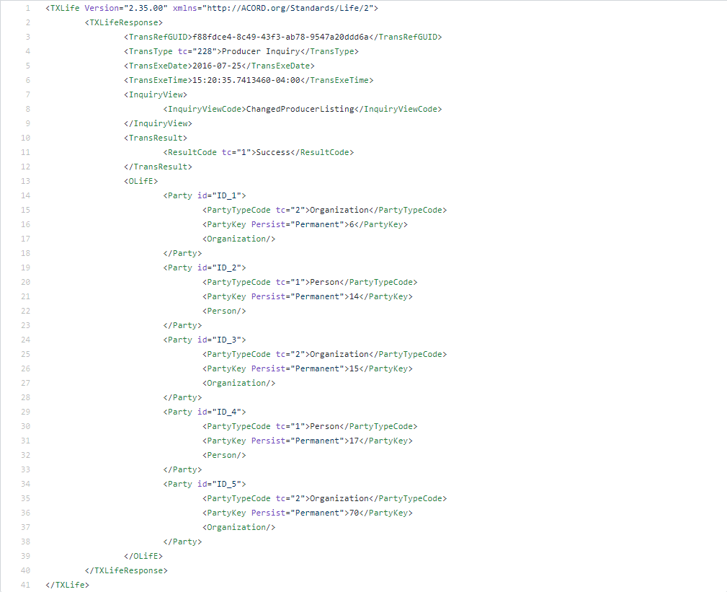

Figure

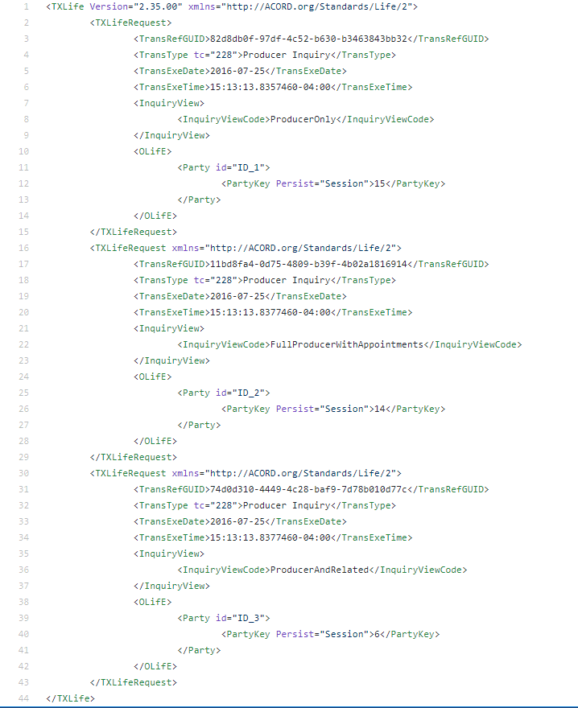

Figure

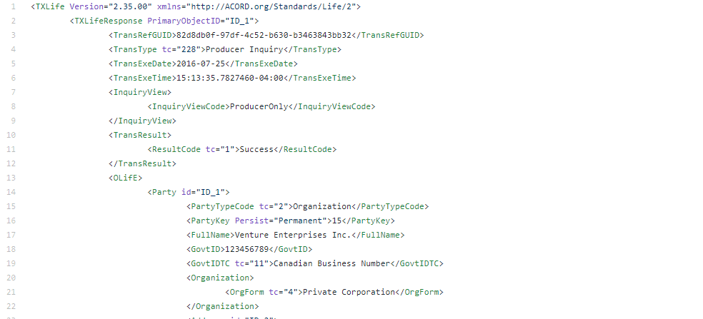

Figure

# Step Three – Applying Business Rules and Logic to Response

As mentioned above, the response for “Multiple Producers by ID” will provide **everything** available for that advisor, corporation or shareholder and not just the items that have changed.

Your organization may choose to over-write the full file in your backoffice with the information contained in the response, regardless of the change.

You may choose to store off the last response for each record and compare to determine if the change is material to your business.

You may only care about one piece of information (licence information, for example) and so if there is licence information included, you will choose to write that back to your back office and if not, you will ignore the record.

How you proceed with the response to the second request is up to your organization.

Note: The pdf documents available in APEXA are provided in the response as a hyperlink to the document location in APEXA. If you wish to download the document this is done through a separate call. See Appendix B for more information.

Appendix A – Request Types

|  |  |
| --- | --- |
| Request | Record Type |
| Advisor with Appointments | Advisors with contracts (in any state) |
| Multiple Producers | All (Advisors, Shareholders and Corporations) |
| Organization Only | Corporations |
| Organization and Shareholders | Corporations and Shareholders |
| Organization with Appointments | Corporations with contracts (in any state) |
| Organization and Shareholders with Appointments | Corporations and Shareholders with contracts (in any state) |

Appendix B – Downloading Documents

To download a pdf out of APEXA, you’ll need to use the “File Retrieval Request.” You’ll pass the URL provided in the “Multiple Producer by ID” response (Sample Request – Figure 5)

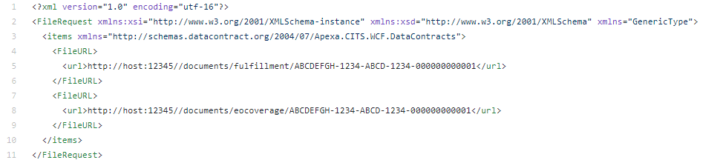

Figure

This will return the pdf document (Sample Response – Figure 6)

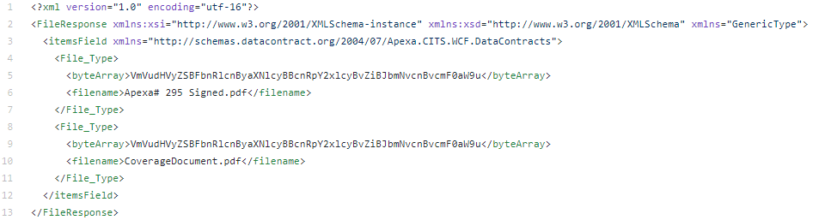

Figure